**How To Run System Info EXE File in The Laptop and Desktop**

**Step 1 — Right-click the ZIP (Image 1):**  
On your Desktop, right-click the System_Info **compressed (zipped) folder** and click **Extract All…**.

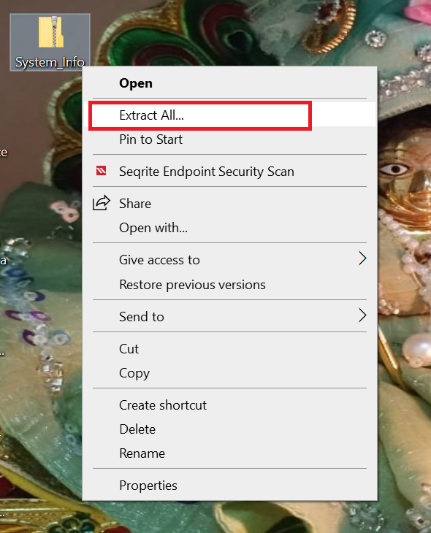

**Step 2 — Choose destination & extract (Image 2):**  
In the **Extract Compressed (Zipped) Folders** window:

* Confirm or change the destination folder.
* (Optional) Leave **Show extracted files when complete** checked.
* Click **Extract**.

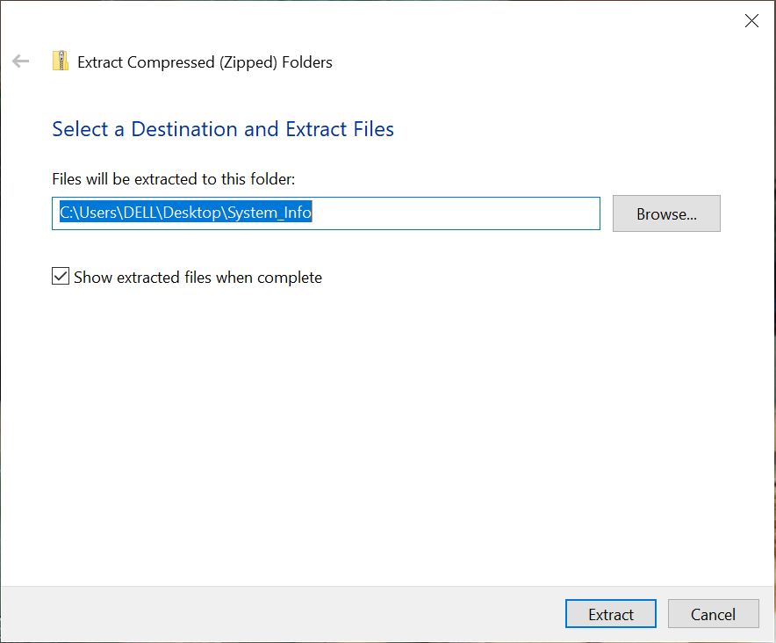

**Alternative with WinRAR (Image 3):**  
If the file shows WinRAR options, right-click it and choose **Extract to System_Info\**.  
This creates a folder with the same name and unzips everything into it.

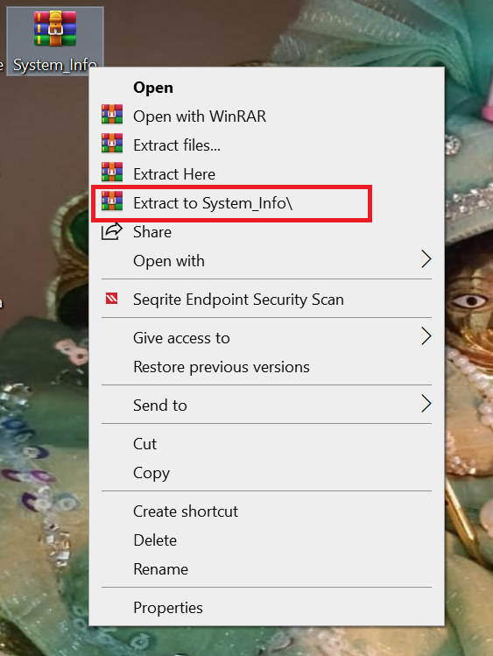

**Step 3 — Open the extracted folder (Image 4):**  
After extraction you’ll have a **normal folder** named System_Info.  
Right-click it and choose **Open** (or just double-click) to view the contents.

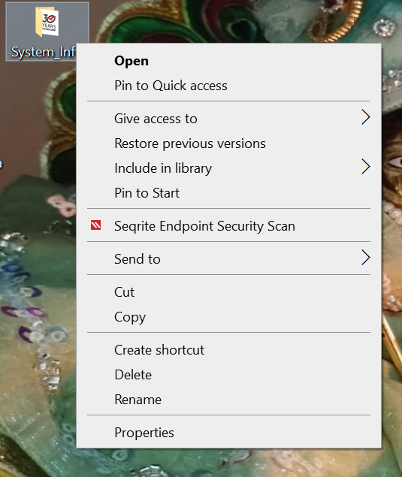

**Step 4 — Locate the EXE file**

Inside the extracted folder, find the application file

**Step 5 — Run as Administrator**

1. **Right-click** on System_Info.exe.
2. Select **Run as administrator** from the context menu.

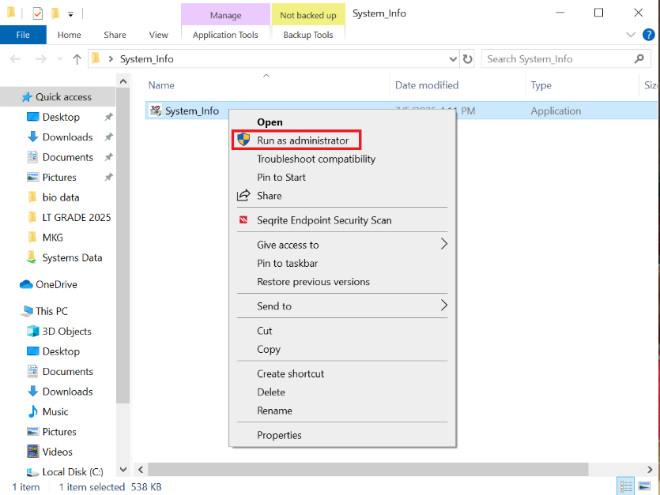

**Step 6 — Confirmation prompt (Image 6)**

A **User Account Control (UAC)** window will appear asking: *Do you want to allow this app to make changes to your device?*

* Click **Yes** to continue.

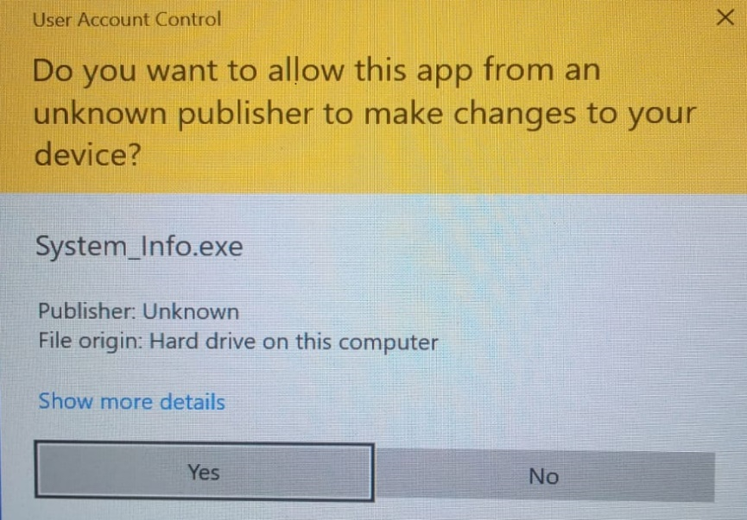

**Step 7 — Program startup**

After clicking Yes, the **System_Info application** will launch.

* A progress/loading screen may appear briefly.

**Step 8 — Begin the process (Image 7)**

Follow the first on-screen instructions shown in the tool to continue.

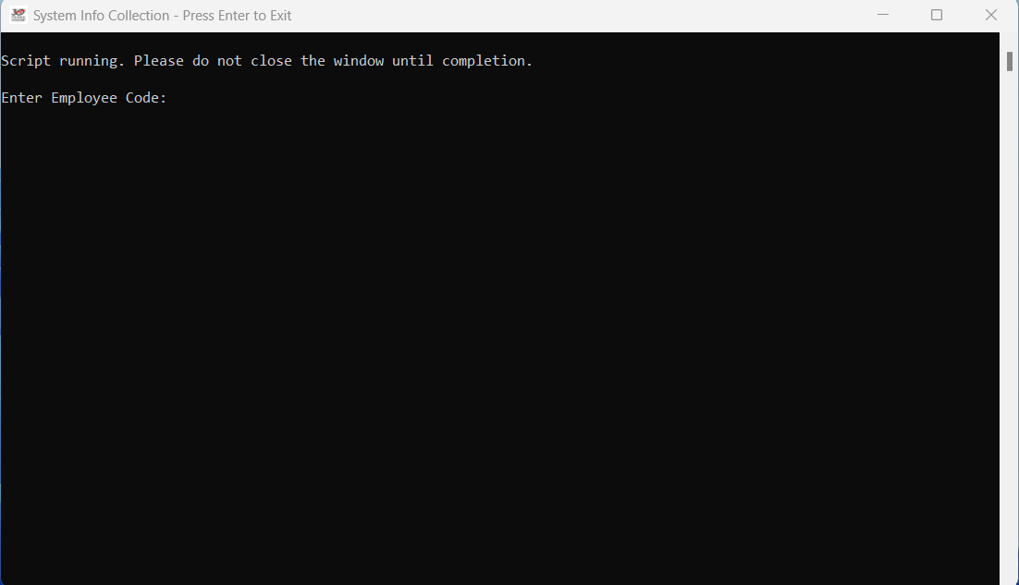

**Step 9 — Enter the requested details (Image 8)**

You’ll be prompted in sequence to provide your details. Type each value and press **Enter** after each line:

* 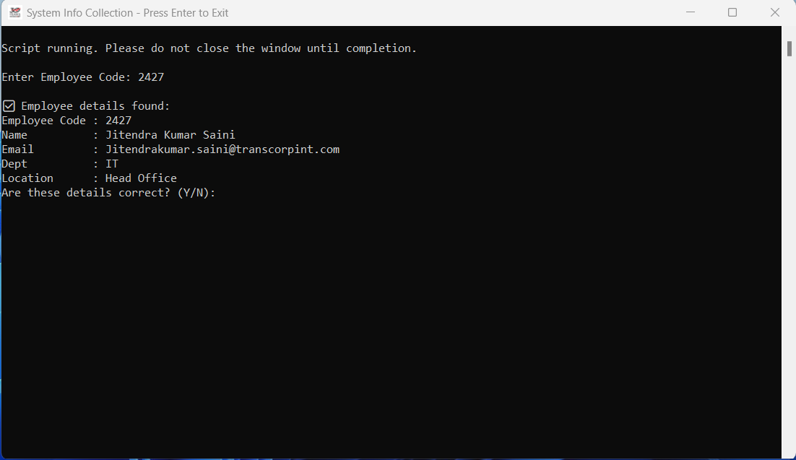**Enter Employee Code:**

After entering the employee code, cross-check your personal information with the found details

If the details are correct, press **Y** and continue.

If the details are incorrect, press **N** to re-enter your Employee Code.

**Step 10 — Again, Enter the requested details (Image 9)**

* **Enter Official Contact Number:**
* **Enter Personal Contact Number:**

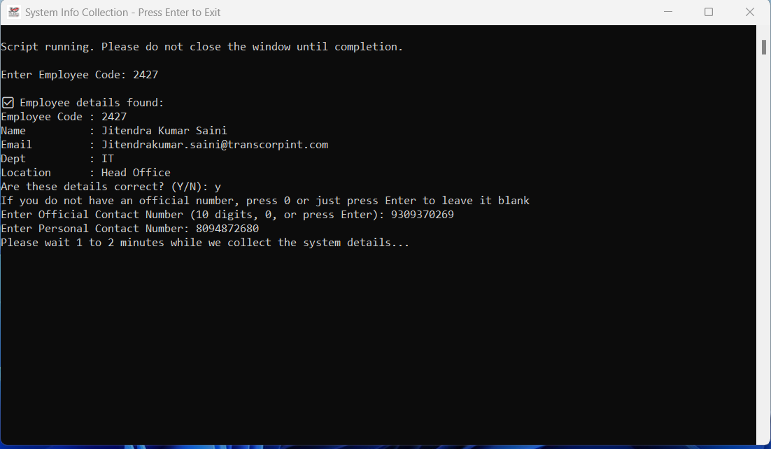

**Step 11 — Wait while the script collects system info (Image 10)**

The tool will automatically gather system details.  
You’ll see a formatted block of results similar to your screenshots, including:

* **Antivirus**
* **DefenderStatus**
* **FirewallStatus**
* **DeviceType (Laptop/Desktop)**
* **UserType (Local/Domain)**
* **LoggedInUsername**
* **DomainOrWorkgroup / DomainController**
* **SystemUptime**
* **BitLockerStatus**
* **DriveUsage**  
  …and also the user information you entered from Step 8.

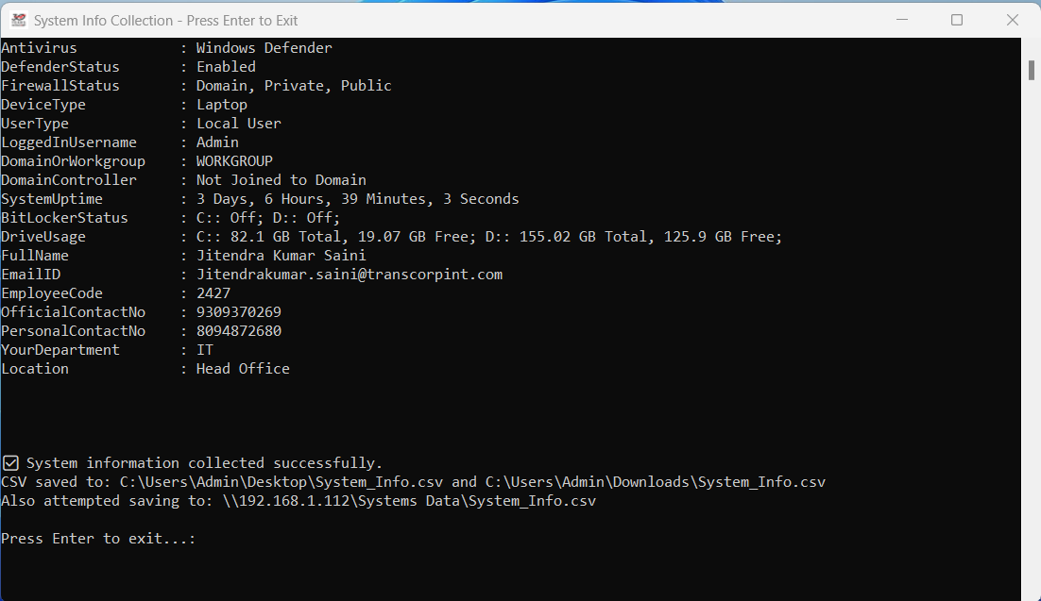

**Step 12 — Exit the tool**

When the process is complete, you’ll see this prompt:

Press Enter to exit...

Press Enter to close the window.